**ERPsim Team Report**

**with Individual Role Reponses**

**May 8th, 2020**

**ISDS 435**

**______________**

**Clifford Kaunang**

**Gee Li**

**Gustin Lowe**

**Kino Jiang**

**Nhi Hoang**

**Team Dynamics – organizational structure and separation of duties**

**o How were decisions made?**

Before the graded game started and in between rounds, decisions were made based upon feedback from the other ex: what worked well and what should we continue doing or, what wasn’t working and what should we try instead. During the rounds, decisions were made based upon information communicated from other team members

**o How were responsibilities divided?**

Responsibilities were divided amongst the group based on what each member felt most comfortable with as well as their overall familiarity with the action. For example, in previous simulations, Kino oversaw regulating the product’s prices. As such her responsibilities would remain the same for the final simulation, this would be applied towards the rest of the team. We found that this method of dividing responsibilities made it easy to communicate updates and information with each other.

**o How did SAP enable, enhance, or restrict the performance of the team?**

SAP enabled the team to segregate duties amongst themselves and have each member focus solely on an area they were familiar with. This allowed for organization of the roles as a member could focus on their task and communicate their actions to the rest, reducing the chance of duplicate actions. However, it did restrict the team, in that it did not allow multiple users to use some transactions simultaneously. For example, if one member wanted to see the price but someone already has access to it. The person who has access would have to leave so that the other person can view it.

**Business Strategy – strategic decision points throughout the process**

**o What was the initial strategy, and why?**

The initial strategy was formed through the metrics and analysis of the data from the practice rounds. We analyzed the data for our team and compared it to the top two performing teams to find out how we could improve.

During the practice rounds, 1kg Original and Mixed Fruit Muesli were two of the three worst sellers for Team EE, HH, and our team. Therefore, we decided to focus less on production and marketing on these two items.

Initially, the independent planning requirements for 1kg Original and Mixed Fruit lot sizes were set to the quantity of 16,000, the smallest lot size, in order to minimize the production time and the lot size for the other items, the lot size for the other ten items was set to the largest lot size 48,000, the largest lot size. The goal of using the largest lot size was to minimize the setup time by having two days of production for every one day of setup time

**o How did the strategy evolve during the process?**

After round 1, our company recognized that we set up a high quantity of production for every product in the independent planning. Thus, it took a long time for the raw materials to be converted into finished goods. In round 2, we decided to focus on producing strawberries and blueberries. We reduced the lot size in the planning quantity from 48,000 down to 13,000 for strawberries and blueberries as our best-selling products and reduced from 16,000 to 8,000 for other products.

After round 2, our company purchased more capacity which increased from 24,000 to 26,000. Thus, starting in round 3, our company kept producing 13,000 strawberries and 13,000 blueberries. However, during the time that we did not have enough raw materials to produce these two products, our company tried to produce the next best-selling products such as raisins and nuts. Also, we decreased the setup time to boost up the productivity.

In our last round, we focused on keeping the products constantly produced so that customers always have something to purchase. We speeded up in communication between Production Manager and Procurement Manager and made sure that MLP was constantly updated so that the production could convert the raw materials smoothly. Also, as the market reactions changed quickly, our company changed the prices more frequently based on the sales data. We also boosted up more marketing to make the products more popular and increase sales.

**o Was the strategy successful? Why or why not?**

Although not all strategies are well reflected in the results, many of our strategies have effectively increased productivity and profits. As our strategies evolved, we found that some were successful, and some were not. The successful side includes the following strategies. First, we were successful in changing planning of increasing capacity through the process. This allows us to order more raw materials and produce more finished goods, thereby greatly increasing production capacity. Second, investing in setting time and conversion time helped in increasing our productivity which can bring more benefits. Third, the strategy of focusing on best -selling products (blueberry, strawberry) made our sales better. Fourth, we changed the ratio of raw materials which allowed us to reduce our costs. However, we still had unsuccessful strategies. We should implement all our successful strategies from the first beginning. Also, we adjusted the price too frequently (especially when decreasing). We should give more time to let the market react to the new price.

**Process Execution – excellence in execution, tactical approach**

**o What approach was taken to executing the procurement, production, and sales processes?**

For procurement, we decided to monitor our raw material inventory. If the inventory is lower than the safety stock level, the procurement manager will run the MRP and create purchase orders. For production, we analyze the sales report to find out our top 4 best-selling products and focus on producing them every day. The MRP runs every day to allow more production to be scheduled. For sales, we set up different selling prices in different distribution channels. Low prices for hypermarkets because they are sensitive to price, high prices for independent grocers because they are not sensitive to price, then we set average prices for grocery stores.

**o How did the execution approach change as the simulation progressed?**

The execution approach for procurement changed as we realized we need to change in the planning to increase the quantity of raw material available to order. In the beginning, we set our quantity too low hence we are always low on inventory and need to order raw material every day. When we change in planning, this means we will not run out of raw material easily and keep our production running every day. For production, if there is not enough raw material to produce the bestselling products, we will produce other products to maintain sales every day. While waiting for raw materials to be delivered, we scheduled finished goods that are available to produce. For sales, if a product is not selling, we decrease the price or increase marketing expenses on it.

**o Was the team successful in executing the cycle efficiently (any problems with excess inventory (i.e. gluts), stock-outs, etc.)?**

Our team was not very successful in executing the cycle efficiently because of excess inventory in round 3 and round 4. As we wanted to boost up our productivity, we ordered a huge amount of raw materials which exceeded the maximum capacity. However, during the simulation process, it turned out that we did not have enough time to convert all the raw materials into production. Thus, our company got charged for $1,000 per day to store the excess inventory, which increased the operating expenses of the company.

**o How did SAP enable, enhance, or restrict the execution of the integrated processes?**

SAP restricted the execution of the integrated process because only basic sorting, filtering and subtotals on one column could be used to analyze the real-time data of the Detailed Sales and Market Price reports. The “Excel in Place” view could not be used because SAP took too long to switch from the table view to the “Excel in Place” view. Once in the ‘Excel in Place” view a pivot table could be created but you could not click the “Refresh Data” button because doing so would erase the pivot table design and then it would have to be recreated.

**Results**

**o What worked, and what did not work? Why?**

Reviewing the overall results, we’ve determined that what did not work was the frequent adjusting of prices. We found that because we changed the price a lot, it caused the value of our company to fluctuate. However, what did work was the prioritization of our blueberry and strawberry products. This allowed us to identify what was our top selling products and allocate more resources towards those products. What also worked was our strategies that were successful. Knowing what successfully works, in the beginning, would allow the company to perform better than it did.

**o What decisions were made that supported positive results?**

Increasing the capacity and reducing the setup time helped to boost up the productivity. Also, better communication between product conversion agent and purchase order agent makes sure that products are constantly produced with enough raw materials. This ensured the available products for customers to constantly purchase, which resulted in higher sales.

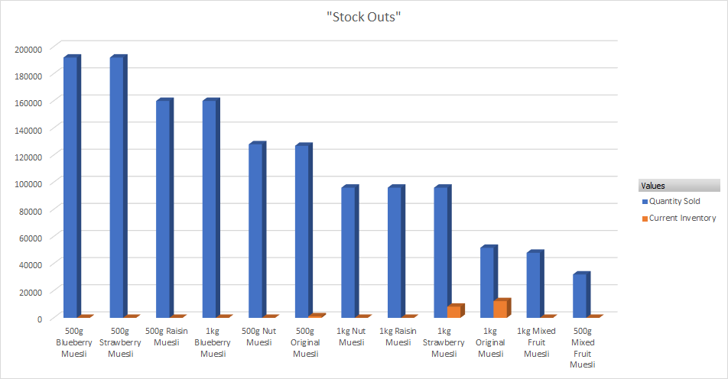

**o What decisions were made that led to negative results?**

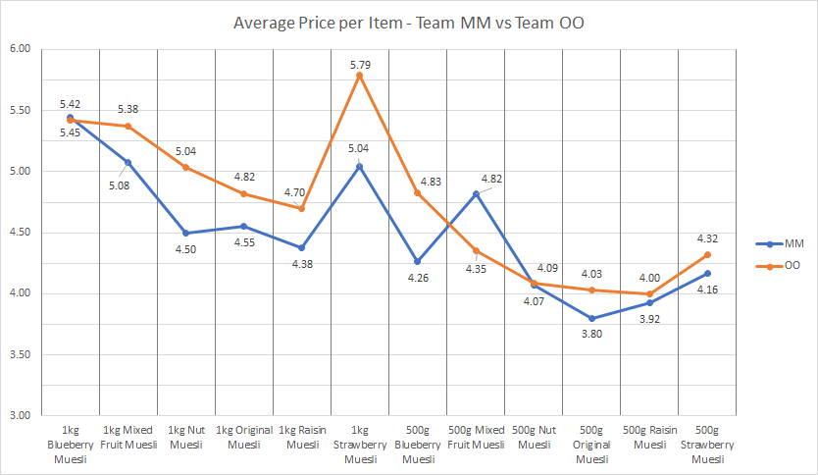

Our initial decisions and strategies are not comprehensive. We did not consider setting time, capacity, and how to prioritize the products. Although we adjusted the strategies from halfway, we still can’t catch up on the gap. Further, we are too cautious about the use of our cash; instead, we should invest more on productivity. In addition, we were focusing too much on sales, which leads to our frequent price adjustments. These are all factors leading to negative results.

**o Knowing then what you know now how would your strategy and tactics have changed?**

In conclusion, in order to increase company value, we should do the following adjustment of strategies. First, we should invest more in capacity and setting times for increasing productivity. Second, we should focus on best-selling products as soon as possible, involving the choice of raw material ordering and production. Also, we should do the predicting analysis before the starting, and set the price range and marketing expense range of each product.

**ROLE RESPONSE**

Member: Clifford Kaunang

Role: Marketing Manager

**Role**

My responsibilities as the Marketing Expense Controller was to determine when we should advertise an item, oversee how much my group would spend on advertising, and regulate the amounts spent in each area (North, South, and West). For instance, if our inventory indicated that we were low on a product then I would decrease marketing for that specific item in all areas. Vice versa, if we noticed that an item was not selling well, I would increase advertising for that one item. In addition, my role required that I communicate primarily with Pricing and Sales Report to gain insight on whether to raise or lower advertising as well as knowing which item to heavily advertise.

In the overall cash-to-cash cycle, the role of Marketing Manager allowed me to regulate how much was spent on advertising on items that were out of stock or close to being out. By reducing marketing on items that are being restocked or reordered and continuing to recognize sales on our current inventory, we can reduce our marketing expenses. In the cash-to-cash cycle, if we are not generating any cash for some time then funds in certain areas of operation, such as marketing, would have to be reduced; so, save money. By controlling how much we spend on marketing during certain periods, this is how my role fits into the cash-to-cash cycle.

**Analytics and Business Intelligence**

The operational reports in SAP can help the Marketing Manager determine whether the business is spending too much or too little on marketing. If the business did not do well in one period, it can review the operational reports and analyze how much money is being spent to run the business. By analyzing the operational report as the Marketing Manager, it can help make decisions on whether to spend on marketing; or if there are enough funds to spend on marketing.

I primarily used the Inventory Report and the insight from the detailed sales reports, to aid in the decision making on marketing. The Inventory Report was used to indicate which item was close to being out of stock, this information helped determine which item to decrease marketing. The information from the detailed sales reports was used to determine which item was popular in what area. This was used to determine how much marketing we should spend on a certain item in an area. As the controller of Marketing Expense, the informational data provided in Excel was used to determine how much would be spent on marketing as a certain item and how much to spend in a certain area.

My role as Marketing Manager did not maximize the use of operational and informational reports to the fullest. In retrospect, had I used both reports in conjunction with one another I would have been able to make better decisions regarding marketing. To elaborate, if I look at the informational reports and see that we could maximize sales if we invest more marketing but know that we are already using all our advertising funds. I can then examine the operational reports to see if there is some extra capital to allocate towards marketing. Had I used both reports conjunctionally, the company would have been able to use the information more effectively.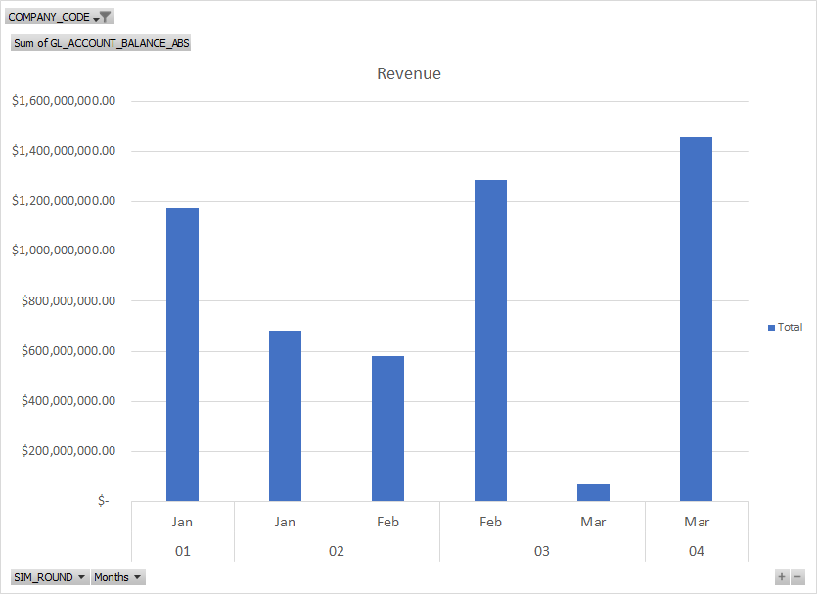

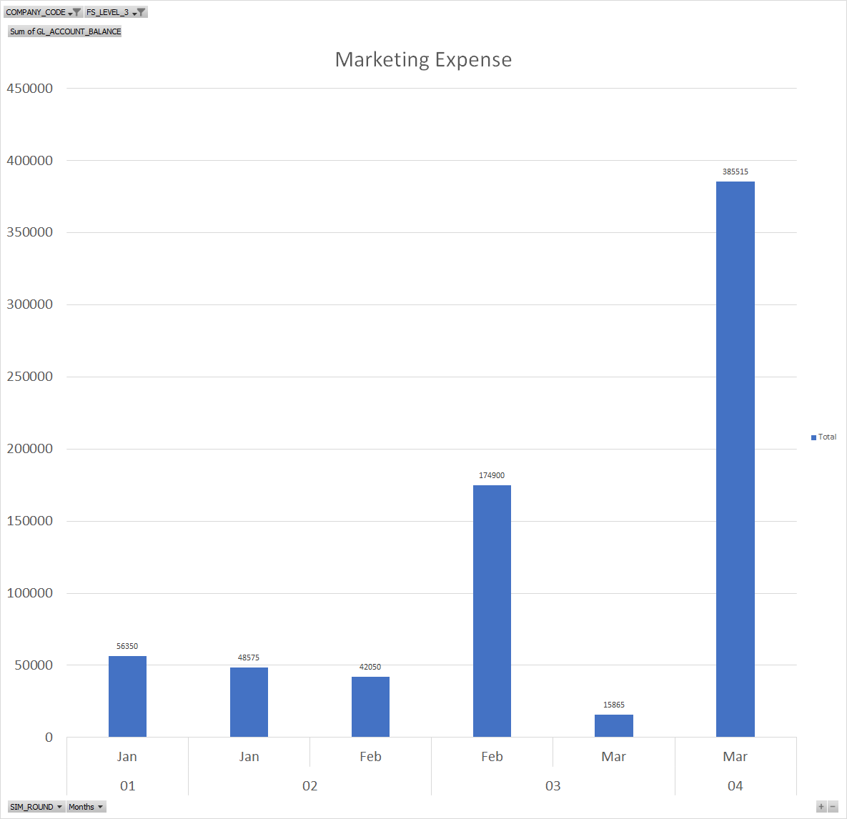

Name: Kino Jiang

Role: Price Manger

**Role**

As a price manager, my main responsibility was to control and adjust the prices of products. I made the decision of price according to the following factors: sales, cost, distribution, and inventory status. Among all the factors, sales had the most important influence on the price; thus, in order to be able to track sales effectively, I worked with the sales manager to check detailed and summary sales reports and adjusted the price. Usually, I would increase the price when the product was selling well and decrease the price when the product was not selling well. At the same time, I needed to be careful not to make the price lower than the cost. Further, I made the adjustment based on inventory status. Basically, I increased the price temporarily when I found there is a low inventory status. In addition, I also considered the place that the product was selling, as known as distribution. For the highly price-sensitive distribution like hypermarkets and grocery stores, I was more cautious of adjusting price; vice versa, for the medium price-sensitive distribution like independent grocery, I adjusted more drastically. Besides, the role also required me to work with a marketing manager to determine the price strategy based on the investment of advertising.

In the overall cash-to-cash cycle, my role is connected to the day's sales outstanding. The operation of the company requires a large amount of cash, and we still had loans that needed to be repaid. The only way to gain cash and revenue is through the sales of our products, and the price is closely related to sales. Therefore, it is important to set a reasonable price that would bring the maximum benefit to the company. That is how my role fits into the cash-to-cash cycle.

**Analytics and Business Intelligence**

The operational reports in SAP have a significant impact on making decisions of price. Throughout the process, I can only determine how to adjust the price by analyzing the operational reports. The most important report I used is a detailed sales report, which helps me track the sales trend of each product daily. Secondly, I used the summary sales report complementary to prevent me from missing anything. In addition, I checked inventory status by using the inventory report. This report indicated which product has low inventory, and then I could adjust the price of the product.

Besides the reports, both Excel and Access were also important tools to help me analyze and record the data and determine how to adjust the price. Using tools like pivot tables, Excel is useful to help me more intuitively grasp the sales of each product in different distributions. Also, data can provide information on how the price influenced sales. Moreover, Excel and Access both help in recording the price and comparing it to the cost, which ensures all the prices are higher than the cost.

Although my work was not the most outstanding contribution to the company, I also made efforts and achieved a certain return. With my adjustments in prices, most products had good sales, and some of them were selling very fast in certain areas. It avoids the excess inventory of goods in the warehouse and reduces the corresponding expenses. Further, it ensured the company had relatively high income and revenue, and the company had never been in a state of loss or cash shortage.

However, compared to other companies, we still have a lot of room to improve. For my role, there are certain ways I can improve and use information more effectively and efficiently. First, I should rely on Excel during the process to do the data analysis. The SAP report can only provide real-time data, but Excel can help me predict the sales trends, analyze how the sales are related to price, and show the relationship between price and distribution. It can be more effective if planning the price in advance. Second, I shouldn’t adjust the price too frequently. Especially when I decrease the price, I should give the market more time to react instead of blindly lowering prices to speed up sales. Third, it can be a good strategy to focus more on best-selling products. It will be more effective and efficient to give priority to adjust the price of the best-selling products instead of trying to adjust all products. I should do the data analysis only for best-selling products and find the price, which can balance the sales and gross profit and give us the maximum revenue.

**Final metrics and graphs**

**The relationship between product price and sales order: (use 500g Blueberry as example)**

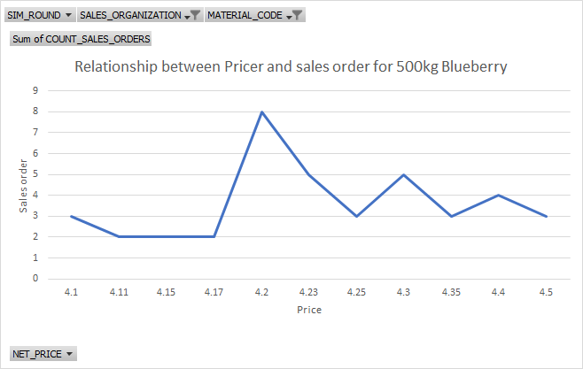

Total Sales changes through rounds

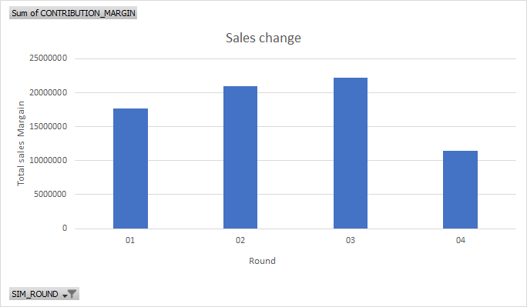

Name: Gee Li

Role: Procurement Manager

**Role**

The responsibilities of my role were to manage the company’s capacity for raw materials and create purchase orders timely to prevent the raw materials run out. Keeping raw material in stock is very important. When the company does not have enough raw material to produce finished goods, our productivity decreases since no production schedule can be made, and our production process is not running at full capacity. If no finished goods can be made, it will affect our sales due to the product out of stock. During the planning phase, our team discussed the demand for raw material based on the popularity of the finished goods. During the rounds, I kept an eye on the raw material inventory report; if the inventory is lower than the safety stock level, I would run the MRP and create purchase orders. After I created a purchase order, I would notify our production manager about the estimated delivery date of raw materials so that she can schedule the production once the raw material is delivered to our factory. I would also run MRP every day to refresh the production schedule so that our production manager can keep scheduling production to produce more finished goods.

My role fit into the overall cash-to-cash cycle because the pricing was fixed, and we ordered promptly, set up our maximum quantity of raw material, and paid our supplier timely. We did not overstock our raw material; hence the cost of sales did not exceed revenue from sales. Therefore, we were still profiting from our sales.

**Analytics and Business Intelligence**

Operational reports in SAP aided in decision making as I needed to discuss with the production manager on which were the best-selling products and plan on focusing the production schedule on those products. During the rounds, I would keep track of the inventory report in SAP to check our raw material inventory. If we are low on inventory, I would run the MRP and create purchase orders. Once the estimated delivery dates were provided, I would inform the production manager to prepare the production schedules.

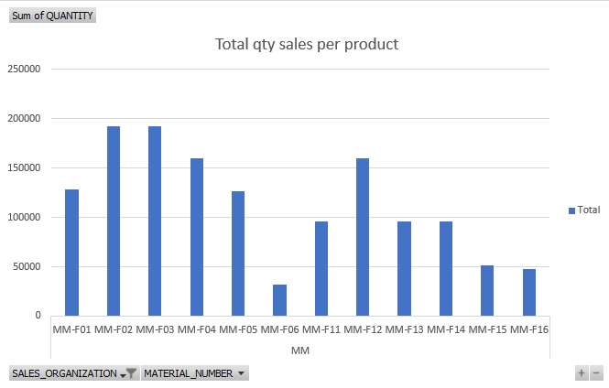

The informational data provided in Excel helps me to plan the safety stock, setting up maximum capacity of the raw inventory, and decide which raw material to order more to prevent shortages which may lead to the production manager unable to proceed any production schedules. Based on the sales data, I found out that 500g blueberry and strawberry muesli cereals are our best-selling products. In the later rounds, I increased the planning of the quantity of boxes, plastic bags, blueberry, strawberry, and oats. Increasing the quantity to order will decrease the order frequency and we do not need to worry about running out of raw material and not being able to produce any finished goods.

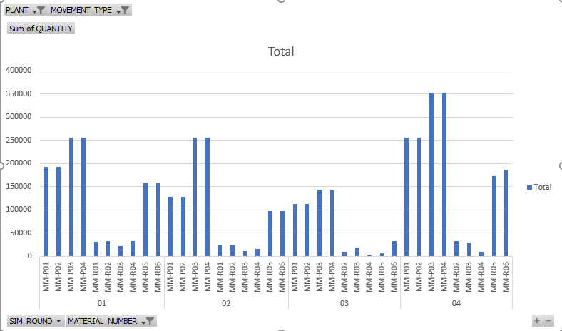

Name: NHI HOANG

Role: Production Manager

**Role**

My responsibilities were conducting product conversion while maintaining effective communication on raw materials with the Procurement Manager. As she announced when the raw materials arrived and were ready to use, I converted those materials into finished goods. At the same time, my core responsibility was ensuring productivity so that products were constantly produced and available for sales to customers. I needed to make sure that raw materials were effectively converted by setting up reasonable capacity and setup time to speed up the process.

In the cash-to-cash cycle, my role was to manage the costs of increasing the production capacity and reducing setup time. For instance, when I increased the capacity from 24,000 to 26,000 items produced per day, it cost the company $1,000,000 in order to produce more. Also, as I converted raw materials into finished goods, our company had enough products available to customers, which indirectly affected sales and brought more cash inflow for the company. If I did not produce finished goods consistently, it could lead the company into out-of-stock status, which would eventually bring down the revenues as customers could not make any purchases.

**Analytics and Business Intelligence**

The operational reports in SAP helped me to keep track of the inventory of finished goods and raw materials so that I could adjust the product conversion efficiently. By looking at the Sales Report and Inventory Report, I could identify which products were selling out and plan to convert the products accordingly. Also, based on the Purchase Order Tracking, I could estimate when raw materials arrived so that I could quickly convert the raw materials into desired products. After the conversion action was initiated, I could keep track when the finished goods were available for sales by tracing the release date on the Production Schedule Report. By flexibly observing the company’s sales and inventory in SAP operational reports, I could effectively make prompt and smart decisions to ensure the efficiency of product conversion.

Using informational data in Excel helped me plan out what I should prioritize during the product conversion process. By creating PivotChart in Excel, I could generate the Sales Report to analyze how customers favor our products and identify the best-selling products of the company. In the chart below, our customers purchased the most in 1kg and 500g Blueberry Muesli and 500g Strawberry Muesli. Thus, I decided to focus on converting strawberries and blueberries into finished goods. At the same time, I needed to communicate with the Procurement Manager to ensure that we always had enough raw materials to convert into our best-selling products effectively. When strawberries and blueberries were out of stock and did not arrive yet, I prioritized producing the next best-selling products, such as 500g Raisin Muesli and 500g Nut Muesli.

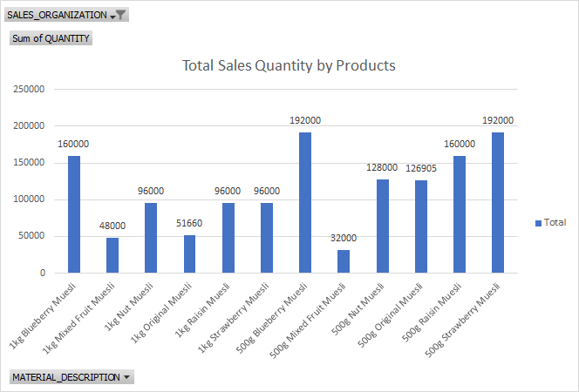

In the production process, it was very important to keep the raw materials constantly converted. The chart below was our company’s production over four rounds. In the first round, we did not communicate very well, and I converted the products without prioritization. However, starting round two, by analyzing the Sales Report, my team and I focused more on converting the best-selling products, hence generating more sales afterward. Also, by effectively using the operational and informational reports, we decided to expand the capacity and decrease the setup rates, which resulted in increased productivity. The data and team collaboration have helped our company bring more products to customers and generate more sales.

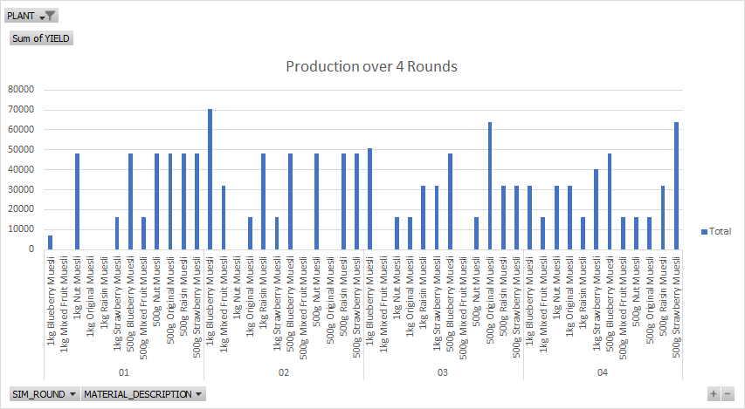

Name: Gustin Lowe

Role: Material Planning & Sales Manager

**Role**

As the Planning and Sales Manager, my responsibilities were to enter the initial independent planning requirements so that the Procurement Manager could order the raw materials needed for production. After each round, I adjusted the requirements based upon our sales, procurement, and production.

After converting the raw materials into finished goods, my responsibility was to increase sales by informing the other managers about our current inventory and how well the products were selling.

In the overall cash-to-cash cycle, my role was involved in the material planning process by generating a sales forecast and creating a production plan and operations plan. Additionally, my role was involved in the sales process by communicating information to the Marketing and Price managers to increase our sales as much as possible. I was also involved in the sales process by telling the Procurement and Production managers about our best selling products so they could make sure to have enough inventory of raw materials and finished goods.

**Analytics and Business Intelligence**

The operational reports in SAP aided in decision making by determining how our products were selling by using the Detailed Sales Summary Report and the Inventory Report. During and after each round, I relayed this information to the other managers so they could adjust the procurement, production, marketing, and pricing as needed.

After round 2, I used the informational data provided in Excel to confirm which products sold the best overall and in each market. Then I shared the information with the other managers. It helped the Marketing manager decide in which market should have more advertising. The Price Manager chose to lower the prices in the market where our products weren’t selling well. From the information, we determined that the strawberry and blueberry muesli were our best sellers. Hence, the Procurement and Production managers ensured that we would have enough raw materials and finished goods so these items would not run out of stock.

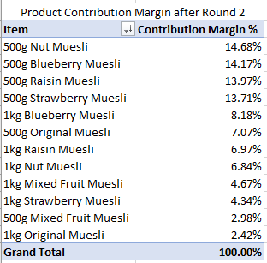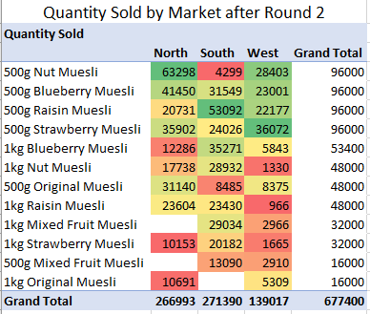

Through the use of operational and informational reports, my role gave our company a competitive advantage in two ways. First, I used a pivot table and conditional formatting on the informational reports to identify our best selling products so we could focus on those and put more effort into marketing and pricing in the area that our products did not sell well. Second, I identified the products with the highest contribution margin. In this way, we could focus on the products that contributed most to our net income. For example, Original and Mixed Fruit Muesli had the lowest contribution margin, so we only produced a small amount of these products.

In retrospect, I set the lot size for most of the products too high. This created bottlenecks in production because it took too long to convert the raw materials into finished goods. Although we noticed this during round 1, we could not change the lot sizes until after round 1 ended. With more analysis on the quantities sold before round 1 started, more productive lot sizes could have been calculated and entered into SAP.

**Final Metrics and Graphs**